**[MongoDB (CRUD) Checkpoint](https://learn.gomycode.co/checkpoints/22d2677c-b0f8-45c1-8554-3c0f0301c5f5)**

* Create a database called "contact"

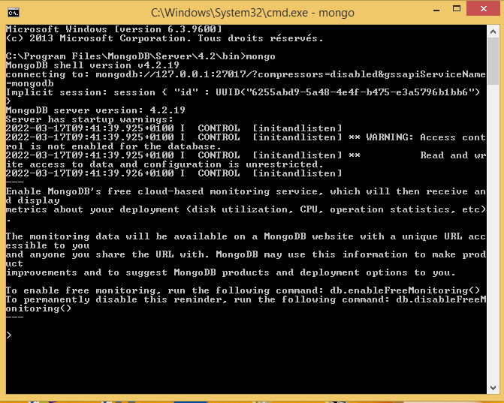

* Create a database called "contact"

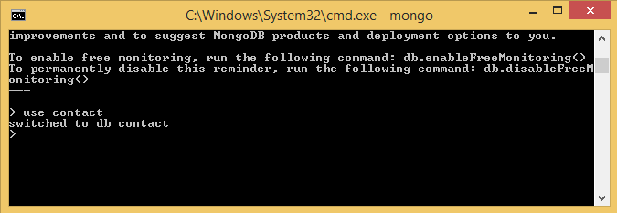

* Create a collection called "contactlist"
* Insert these documents  in "contactlist" :
  + Last name: Ben Lahmer, First name: Fares, Email: fares@gmail.com, age:26
  + Last name: Kefi, First name: Seif, Email: kefi@gmail.com, age:15
  + Last name: Fatnassi, First name: Sarra, Email: sarra.f@gmail.com, age:40
  + Last name: Ben Yahia, First name: Rym, age:4
  + Last name: Cherif, First name: Sami, age:3

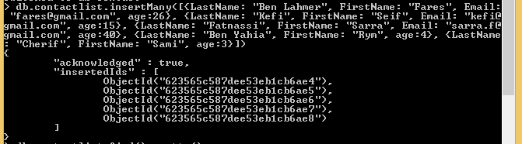

* Display all of the contacts list

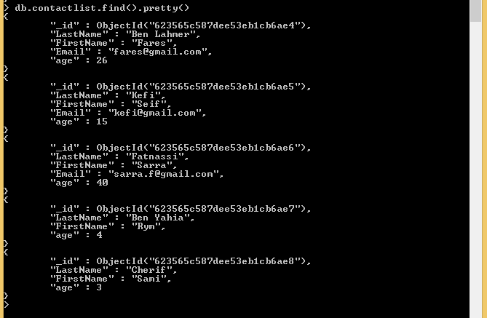

* Display all the information about only one person using his ID.

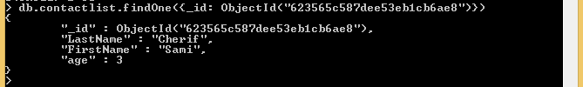

* Display all the contacts with an age >18.

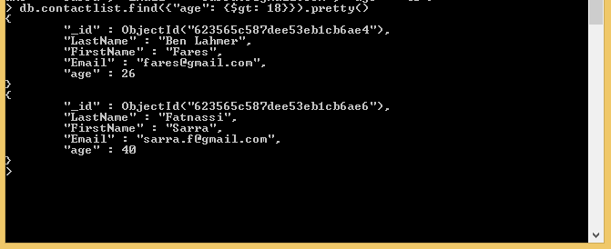

* Display all the contacts with an age>18 and name containing "ah".

G:\GoMyCode 02 03 2022 test\test4Node\mongo\capture ecran\9.PNG

* Change the contact's first name from"Kefi Seif" to "Kefi Anis".

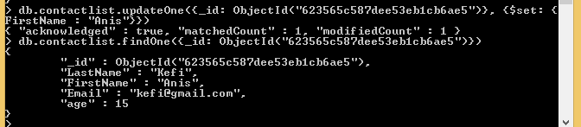

* Delete the contacts that are aged under <5.

G:\GoMyCode 02 03 2022 test\test4Node\mongo\capture ecran\11.PNG

* Display all of the contacts list.

